REQUEST FOR PROPOSALS
Event Planners and Event Management Services
To Manage and Coordinate 2017 TXOLAN Sweetheart Spectacular Alpaca Show
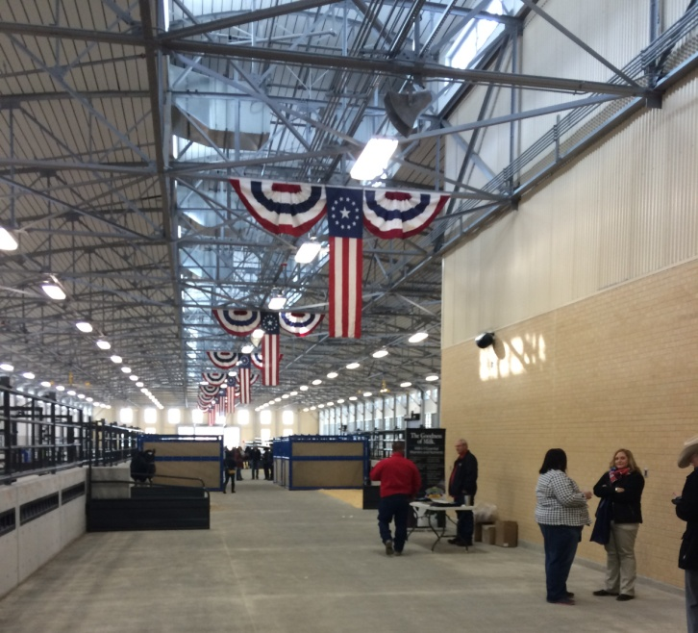

The 18th Annual TXOLAN Sweetheart Spectacular is inviting Event Planners and providers of Event Management Services to submit proposals to plan and coordinate the annual alpaca event to include AOA sanctioned competitive show, education and auction segments all which will occur in Fort Worth, Texas from February 10-12, 2017.

TABLE OF CONTENTS:
- Overview
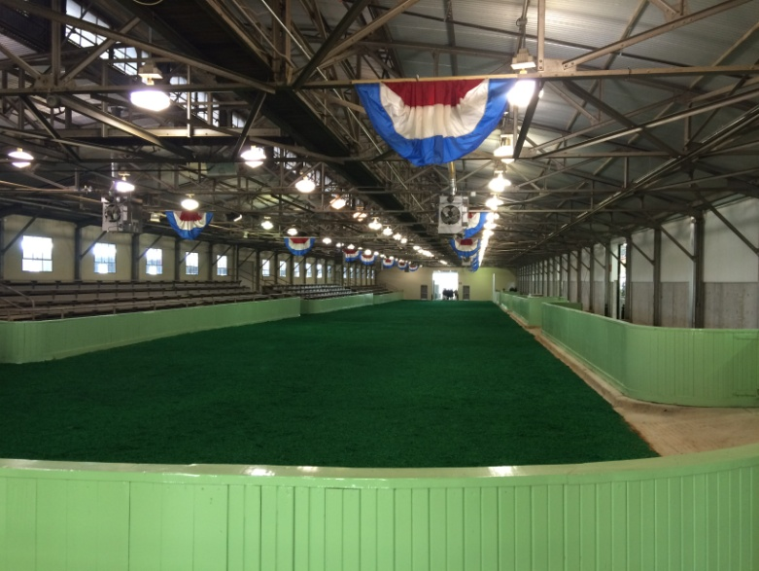
- Organization Information
- Event Description
- Applicant RFP Receipt
- Applicant Information
- Report To
- Status
- Scope of Work
- Project Schedule
- Qualifications
- Job Location
Arena floor will not be green shavings!
- Selection
- Send Proposals To:

OVERVIEW:
This applicant will contra ct with the TXOLAN Alpaca Association to plan, coordinate and execute the specific event. Applicant will manage the execution of defined aspects of the TXOLAN Sweetheart Spectacular as shown in included spreadsheet of activities. This listing is subject to revision based on input from selected applicant though will include contract executions, development, planning, day of coordination, overall event management logistics, budget management, programming, implementation, and analysis. For more detailed information see the Scope of Work section below.

ORGANIZATION INFORMATION:
TXOLAN is an official regional affiliate of the national organization, Alpaca Owners Association, Inc. TXOLAN is an acronym for the 5 state region we represent – Texas, Oklahoma, Louisiana, Arkansas and New Mexico. We also have members from around the U.S.A. that are interested in supporting this region for a variety of reasons which may range from show participation to partnerships with ranches primarily located within these 5 states. This non-profit association offers alpaca breeders, fleece enthusiasts and others an opportunity to work toward excellence in an industry dedicated to promoting alpacas through education, marketing and networking with similar interests in becoming more involved in our business.
AOA (Alpaca Owners Association, Inc.) is located in Lincoln, Nebraska. If you go to their website (www.alpacainfo.com) you will discover the history of the association and find many valuable educational resources about alpacas and the highly desirable end products made from this fine animal's fiber. Additionally, the national organization is responsible for maintenance of a DNA registry used for scientific research and by most breeders within the industry when making the variety of decisions involved in progressing this unique breed of livestock.

EVENT DESCRIPTION:
The annual TXOLAN Sweetheart Spectacular will take place in Fort Worth, Texas on February 10-12, 2017. Event hours will run from 8-5 on Friday and Saturday and are planned for 8-12 on Sunday. Sunday’s timing is flexible as it depends on the numbers of animals and speed of judging the variety of classes though history indicates that this is a good target. There is also a dinner on Saturday evening within the venue complex area and a reception on Friday evening within the competition venue itself. This will be the 18th annual Spectacular.
The 2016 event showcased approximately 320 alpacas and the vision is to exceed that number in 2017. In addition, merchants have excellent opportunities to display and sell their products and services and are welcome to advertise their presence to other events that may be occurring the same weekend within the overall Will Rogers complex.

APPLICANT RFP RECEPTION:
By responding to this RFP the applicant agrees to be responsible for fully understanding the requirements of the RFP and will ask any questions to make sure that understanding is gained. The TXOLAN Board of Directors reserves the right to reject any or all responses to the RFP, to advertise for new responses, or to accept any RFP response deemed to be in the best interests of TXOLAN.
Acceptance of any RFP should not be construed as a contract nor shall indicate any commitment on the part of TXOLAN for any future action. The RFP does not commit the TXOLAN Association to pay for any costs incurred in the submission of a response to this RFP or for any cost incurred prior to the execution of a final contract.

APPLICANT INFORMATION:
All applicants must submit the following information:
  - Name and Overview: Name and # of employees
ii Services: Description of services offered
- Customer and Event References: List of similar events in the scope and industry
- Written Draft Event Description of the proposed event that specifies theme, budget, marketing plan and timeline. The description should define the overall concept of the event. The budget for this event is being finalized though will be between $40-75,000. This does not include applicant fee but does include: marketing, promotions, entertainment and other logistical costs.
- Resume
- Sample Festival/Event PowerPoint Presentation: This would be a sample from the applicant of previously completed work where applicant has planned and executed the event. This sample will concisely demonstrate various key facets such as research that may have been required, design, planning, calendar, logistical needs, budget, and evaluation of that event and its successful completion. This presentation should be saved on a labeled USB drive and included with submittal of RFP.

- REPORT TO:
The applicant will report to the Board of Director Member-at-Large/Show Liaison of the TXOLAN Association.

STATUS:
Contract

SCOPE OF WORK:
  - Develop, manage and execute master event logistical plan and timeline (an example spreadsheet of expected plan is included for overview purposes and is representative versus comprehensive). Some key tasks will already be completed by time of RFP implementation including contracting of Show Supervisor, Show Judges and Facility. However, execution and oversight of same will be expected.
  - Assign and delegate tasks to volunteer teams; evaluate, analyze and report results for the event.
  - Create, manage and reconcile event budgets, expenses and timelines. Adhere to project timelines and budget guidelines.
  - Oversee the implementation of the marketing campaign.
  - Responsible for lea ding / managing various event planning teams in the planning and implementation process for all aspects of the event, which includes attending regular TXOLAN Board of Director or special TXOLAN Spectacular meetings and meeting follow-up.
  - Deliver project deliverables on-time, on-budget and to client expectations
  - Direct and manage volunteer committees, both pre-event and on-site.
  - Manage relationships with event vendors.
  - Direct and manage on-site event set up and clean-up.
  - Manage and execute event debrief as well as recommended improvements/changes.

PROJECT SCHEDULE:
This schedule is based on our current guidelines but is subject to change:
August 23, 2016: RFP Delivered
September 1, 2016: Last day for written questions to be received on the RFP document intent.
September 9, 2016: RFP Close Date
September 1, 2016: Start Applicant Evaluations
September 15, 2016: Awa rd Contract

JOB QUALIFICATIONS:
  - Education: Bachelor's degree in Events Management preferred.
  - Experience: Minimum 2-4 years experience in all aspects of event planning including competitive alpaca show and outdoor/arena event experience
  - Experience managing volunteer team
  - Experience managing event budgets
  - Excellent organization, project management, and perhaps most important, Communication skills.
  - Energetic, innovative, creative self-starter
  - Problem solver and results oriented
  - Able to work well under pressure of event dead lines
  - Ability to prioritize tasks in a fast paced environment

JOB LOCATION:
Fort Worth, TX

SELECTION:
Applicants who have demonstrated the capacity to meet our requirements will be notified via phone / email of our selection to move forward with the RFP Process.

SEND PROPOSALS TO:
Responses must be sealed and clearly marked with the following: “RFP Response – TXOLAN 2017 Spectacular”. Submittals must be received no later than 5:00 pm on September 9, 2016, and should be delivered to:
Larry Ferguson
TXOLAN Board of Directors Member at Large and Show Liason
2311 Bois D Arc Lane
Midlothian, TX 76065
ldfprojectmanager@msn.com
(817) 269-3997

Any questions or clarifications regarding definitions or interpretations of this RFP must be submitted via email no later than September 1, 2016 to Larry at ldfprojectmanager@msn.com.

