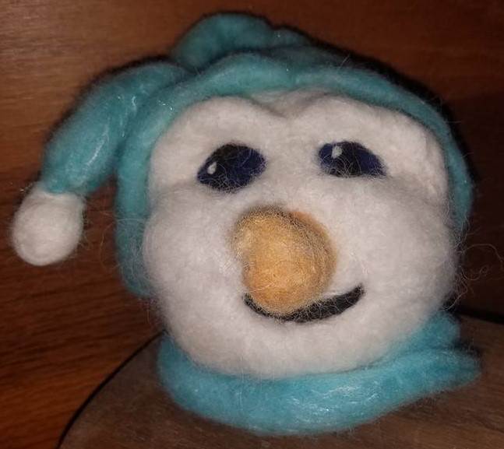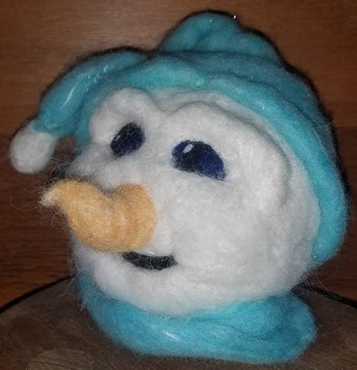

PRE REGISTRATION IS HIGHLY RECOMMENDED

TO REGISTER CONTACT

ALPACAS OF INDIAN POINT HILLS

RHONDA LEINBERGER

217-632-2590

[indianpointhills@gotsky.com](mailto:indianpointhills@gotsky.com)

Make this needle felted snowman face using alpaca and wool fibers!

Class includes materials. Leave class with a completed snowman face.

Saturday, December 9, 2017

1:00 PM

Athens Municipal Library, Athens Illinois

Cost $35.00

NEEDLE FELTING CLASS